


Food Connect

( To supply leftover food to poor )

Project Objectives

The FoodConnect Initiative is designed to achieve several key objectives that support a comprehensive volunteer management system, particularly in the context of food distribution logistics. The objectives are strategically aligned to enhance efficiency, accuracy, and engagement within the Salesforce environment.

- Efficient Task Distribution and Allocation

  - Develop an intelligent task assignment system that matches volunteer availability and location data with distribution events. This ensures timely task completion and maximizes resource utility across venues and drop-off points.

- Enhanced Data Management and Integrity

  - Implement a data validation and synchronization protocol to maintain the accuracy of records for all venues and drop-off locations. This effort minimizes inconsistencies and equips all stakeholders with consistent, reliable data.

- Streamlined Communication Channels

  - Facilitate real-time communication through in-platform messaging and notification systems, ensuring that all participants receive timely updates on their responsibilities and any adjustments to distribution plans.

- Volunteer Engagement and Satisfaction

  - Incorporate feedback loops and satisfaction metrics to monitor and improve the volunteer experience, promoting long-term engagement and retention among participants.
- Integrated Reporting and Analysis

  - Create a reporting dashboard within Salesforce to track distribution metrics, task completion rates, volunteer hours, and other key performance indicators. This provides actionable insights to support ongoing improvements and alignment with organizational goals
Objectives

The FoodConnect Initiative’s objectives are centered on achieving key business goals and specific technical outcomes to optimize volunteer management and food distribution logistics.

Business Goals

- Boost Volunteer Management Efficiency

  - Implement a structured task assignment system to reduce coordination time, enhancing volunteer engagement by simplifying their roles and responsibilities.
- Increase Data Accuracy and Reliability

  - Establish protocols to maintain accurate, up-to-date data on venues, drop-off points, and volunteer information, ensuring easy accessibility and dependable information flow.

- Enhance Communication and Coordination

  - Develop a robust communication platform to facilitate clear, efficient interactions between volunteers, coordinators, and other stakeholders involved in the food distribution chain.

Specific Outcomes

- Development of Custom Objects

  - Design custom objects within Salesforce to organize and manage data associated with Venues, Drop-Off Points, Tasks, Volunteers, and Execution Details, enabling efficient data retrieval and organization.
- Creation of a User-Centric Lightning App

  - Build a Lightning App with a user-friendly interface that provides seamless access to essential information, making navigation intuitive across different functionalities.
- Implementation of Strategic Sharing Rules

  - Define sharing rules to control data visibility based on geographical distance, allowing volunteers to view tasks and information that are relevant to their specific locations.

○

3.Salesforce Key Features and Concepts Utilized

To achieve the project objectives, the following Salesforce features and concepts have been utilized:

- Custom Objects:

  - Venues: This object stores information about locations where food distribution activities are planned. Key fields may include Venue Name, Address, Capacity, and Contact Information.
  - Drop-Off Points: This object captures details about specific locations where food will be delivered, ensuring that volunteers know where to go for food pick-up.

  - Tasks: This object tracks specific assignments given to volunteers, including details such as Task Name, Description, Due Date, and Assigned Volunteer.

  - Volunteers: This object maintains records of all individuals participating in the program, including contact information and availability status.

  - Execution Details: This object logs the details of tasks completed by volunteers, providing a record of their contributions.
- Relationships:

  - Master-Detail and Lookup Relationships: Establishing relationships between objects defines how data is interconnected. For example, a Task may have a Master-Detail relationship with Execution Details, indicating that each task can have multiple execution records. A Lookup relationship might exist between Volunteers and Drop-Off Points, enabling easy tracking of which volunteers are assigned to which drop-off locations.

- Flows:

  - Utilizing Salesforce Flow, we can automate the process of creating Venue records and streamline user interactions by guiding users through a series of steps to ensure all necessary information is collected.
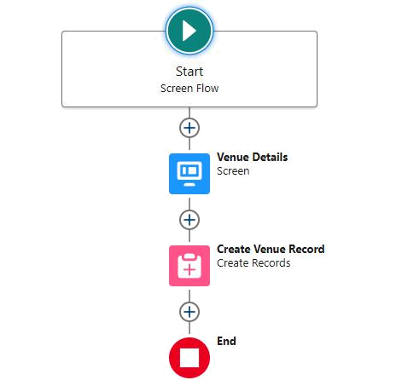

- Triggers:

  - Implementing Apex triggers allows for automated actions based on specific criteria, such as calculating distances between venues and volunteers’ locations when records are created or updated.
- Reports and Dashboards:

  - Custom reports and dashboards visualize data related to volunteer activities, tracking metrics such as the number of tasks completed, hours logged by volunteers, and food distribution statistics.

4.Detailed Steps to Solution Design

The following steps outline the process of designing and implementing the FoodConnect solution:

A. Creating Developer Account:

- Sign up for a Salesforce Developer account, which will serve as the testing and development environment for the project.

- Activate the account via the verification email to gain access to Salesforce features.
B. Creating Custom Objects:

  - Navigate to the Object Manager in Salesforce Setup to create the custom objects listed above. Each object will include fields tailored to capture relevant data accurately.

- Creating Custom Tabs:

  - Create custom tabs for each of the newly created objects, facilitating easy navigation for users within the Salesforce interface.

- Creating a Lightning App:

  - Use the App Manager to create a new Lightning App named "FoodConnect."

  - Add relevant navigation items (custom objects and reports) and assign user profiles to ensure that only authorized users can access specific functionalities.

- Establishing Relationships:

  - In the Object Manager, create Lookup and Master-Detail relationship fields as needed to define how data is connected. This will allow for efficient data retrieval and reporting.

- Creating Fields for Each Object:

  - For each custom object, define the necessary fields, including data types (e.g., Text, Number, Date) and attributes (e.g., Required, Unique). This ensures that all relevant information is captured.

- Creating Flows:

  - Design a screen flow for capturing Venue details that allows users to enter information seamlessly. Automate record creation to ensure that data is accurately logged.

- Creating Triggers:

  - Implement Apex triggers to automate calculations, such as determining the distance between volunteers and venues. This feature will ensure that volunteers are assigned to the closest tasks, improving efficiency.

- User Creation and Management:

  - Create user profiles for different stakeholder groups, including volunteers and administrators. Assign appropriate permissions to each profile to control access to data and functionalities.
J. Report Types and Dashboards:

- Define custom report types to track volunteer activities, and create dashboards to visualize key metrics related to food distribution and volunteer engagement.

5.Testing and Validation

A comprehensive testing phase ensures the system operates as intended:

- Unit Testing: Conduct unit tests on Apex classes and triggers to verify their functionality and performance under various conditions.
- User Interface Testing: Validate the user interface to ensure that it is intuitive and user-friendly, allowing all users to navigate and complete tasks efficiently.

6.Key Scenarios Addressed by Salesforce in the Implementation Project

The implementation of the FoodConnect project has effectively addressed several key scenarios:

- Managing Volunteer Assignments: Volunteers can be assigned tasks based on their availability and location, optimizing the food distribution process.
- Tracking Food Distribution: The system tracks food distribution through various venues and drop-off points, allowing coordinators to monitor progress and efficiency.

- Reporting on Volunteer Activities: Reports generated from the system provide insights into volunteer activities, including tasks completed and feedback received, helping to improve future operations.

Conclusion

The FoodConnect project successfully established a comprehensive volunteer management system within Salesforce, achieving significant improvements in data management, user experience, and operational efficiency. The implementation of custom objects, relationships, and automation features has streamlined food distribution processes, enhancing the organization's ability to coordinate volunteer efforts effectively. This project lays a solid foundation for future enhancements, scalability, and the potential integration of additional features that could further optimize food distribution logistics.
As the project progresses, continued monitoring, user feedback, and iterative improvements will be essential to ensure the system remains aligned with the evolving needs of the organization and its volunteers.
venues
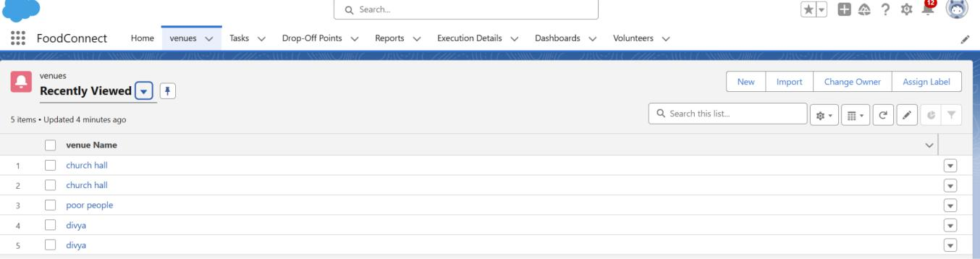

Tasks
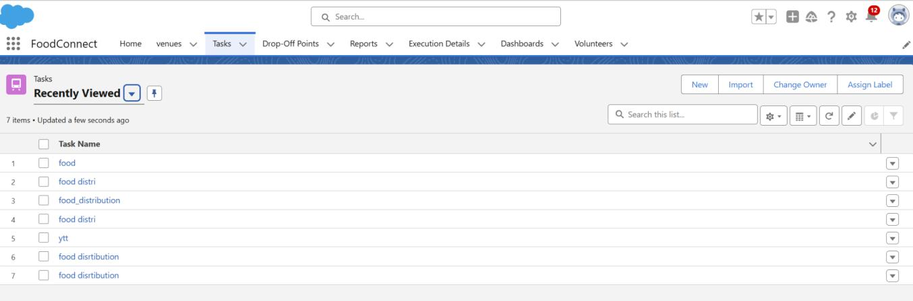

Drop-off point
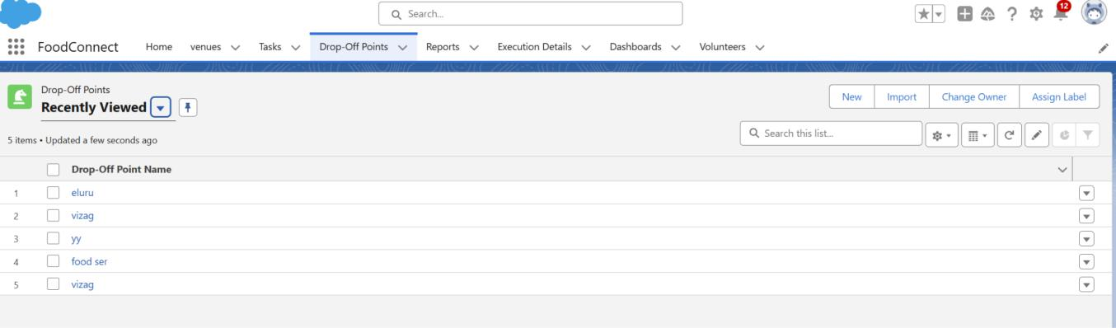
Volunteers
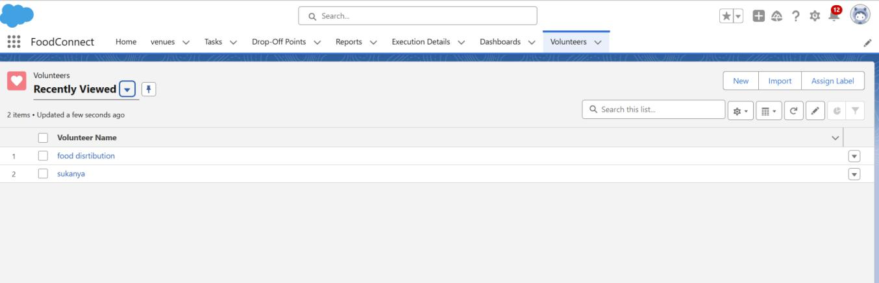

Reports
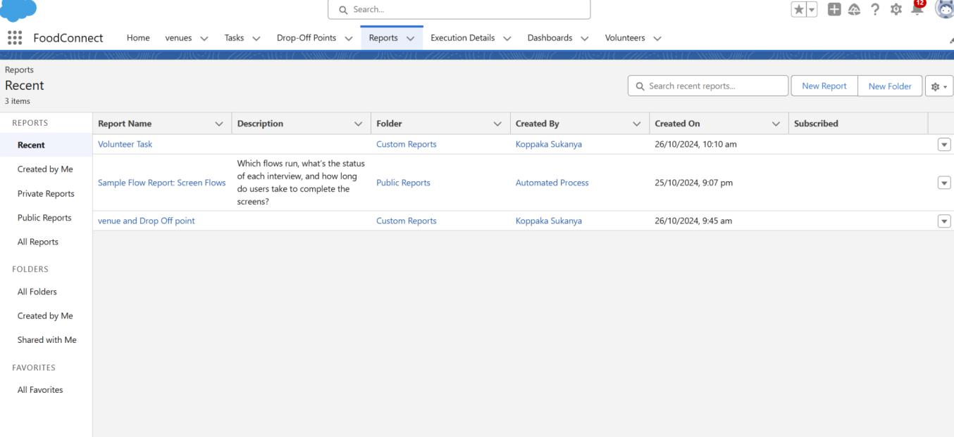
Dashboard
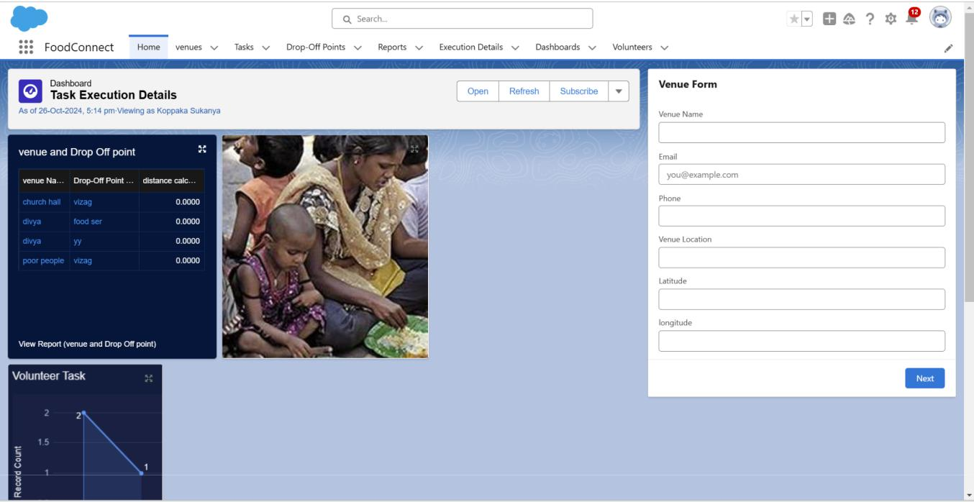

Koppaka Sukanya

Vishnu institute of technology

